RENEWS Tool Standard Operating Procedure
- Download the RENEWS Tool .exe file and the Current Reactors Excel file from {insert website}. The Excel file includes information regarding all current reactors. If desired, add additional reactors using the exact same format as the original Excel file.
- Run the .exe file. The following screen will appear.
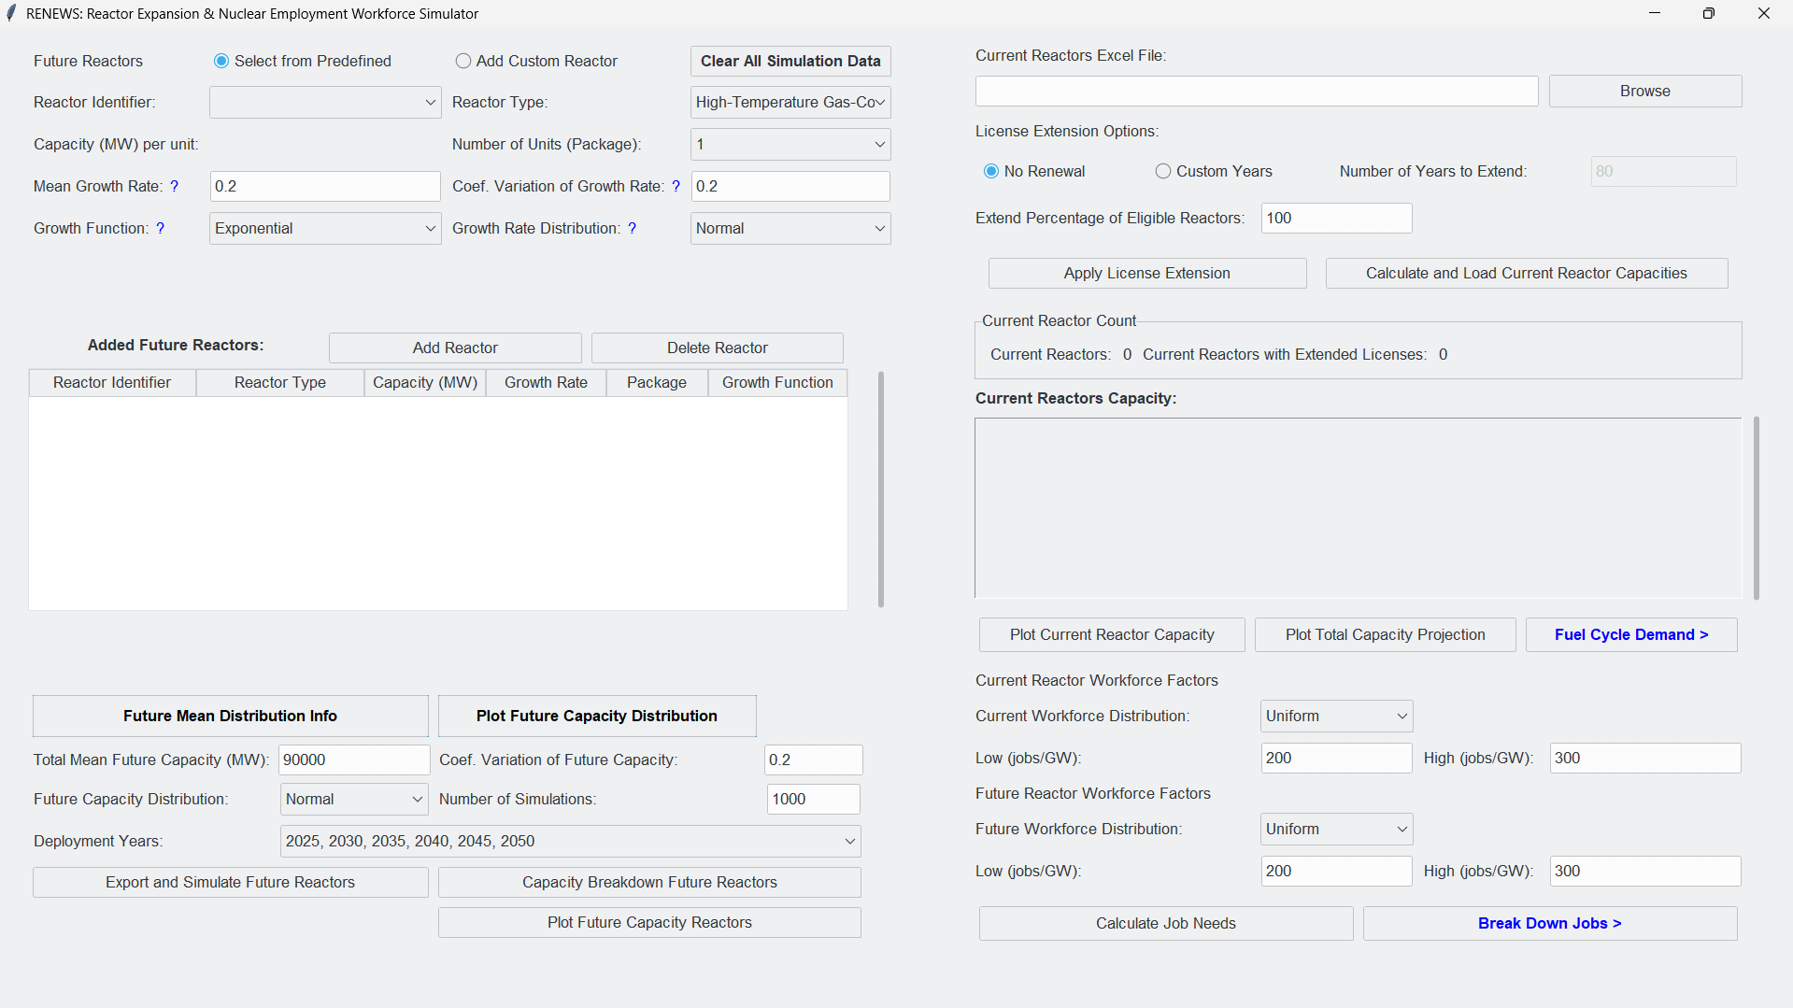
Initial display of the RENEWS tool
- In the Future Reactors section, add reactors to the simulation by selecting from Predefined Reactors OR by selecting Add Custom Reactor and manually inputting the expected reactor properties (number of units, capacity, growth rate, coefficient of variation, growth function and growth rate distribution).
Future Reactors selections
- Once complete, select Add Reactor to add the reactor.
- If necessary, select Delete Reactor to remove the added reactor.
Add/Delete Reactor features
- Repeat until all desired reactors are input in the simulation.
- All properly added reactors will be displayed in the Added Future Reactors section.

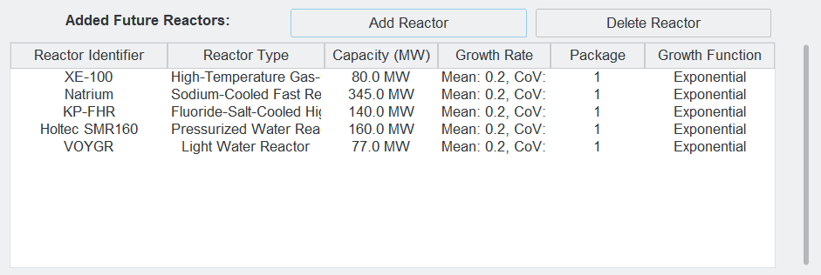
Example inputs for the Future Reactors section
- Input the simulation properties such as Total Mean Future Capacity, Coefficient of Variation of Future Capacity, Future Capacity Distribution, Number of Simulations, and Deployment Years.
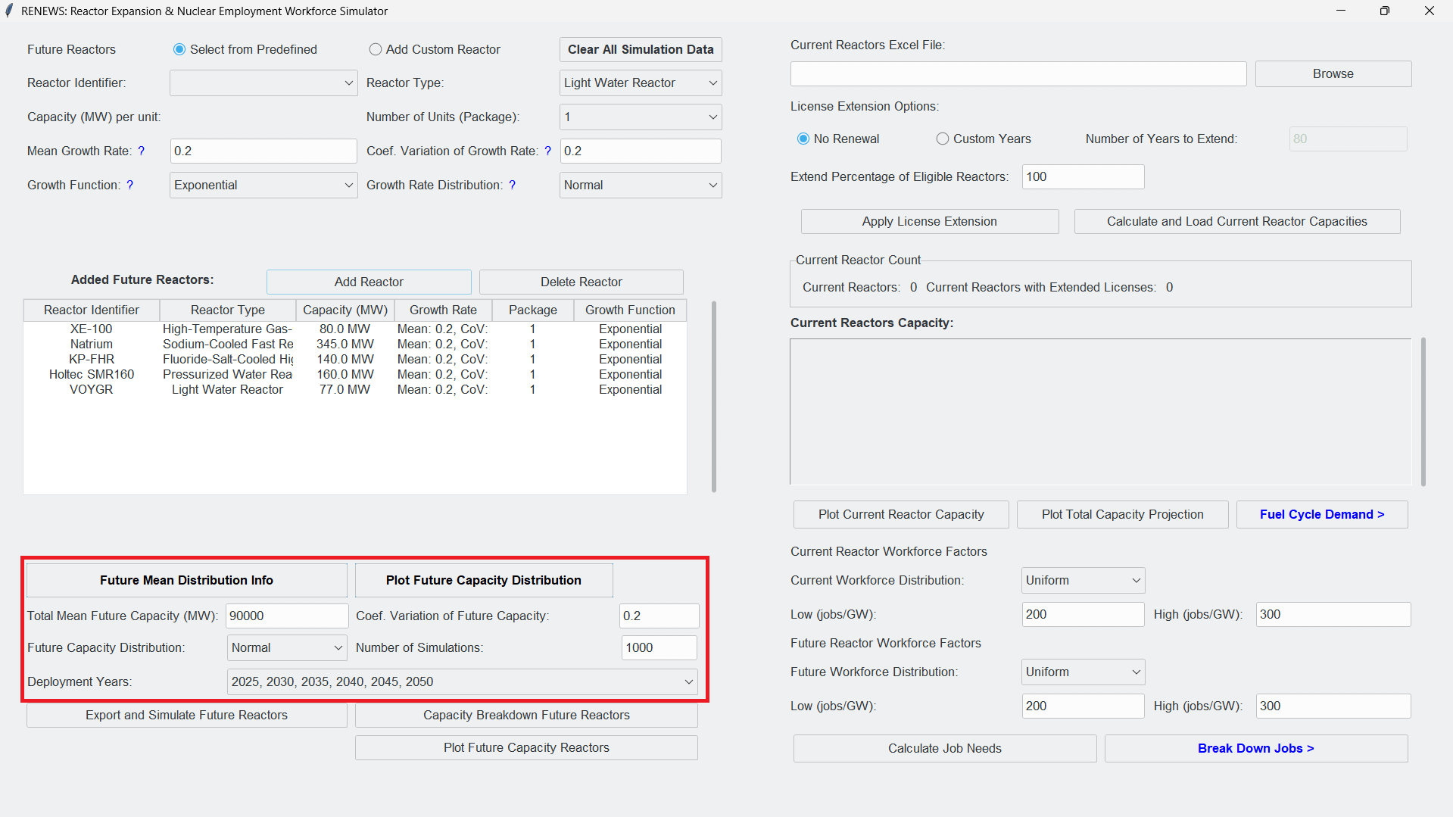
RENEWS Tool display, annotated to highlight the simulation properties
- Once this section is complete, select Plot Future Capacity Distribution to display the distribution on the future capacity
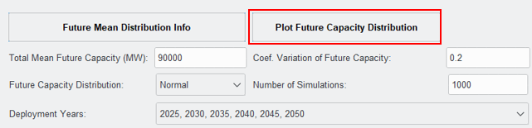
Simulation properties, annotated to highlight the Plot Future Capacity Distribution feature
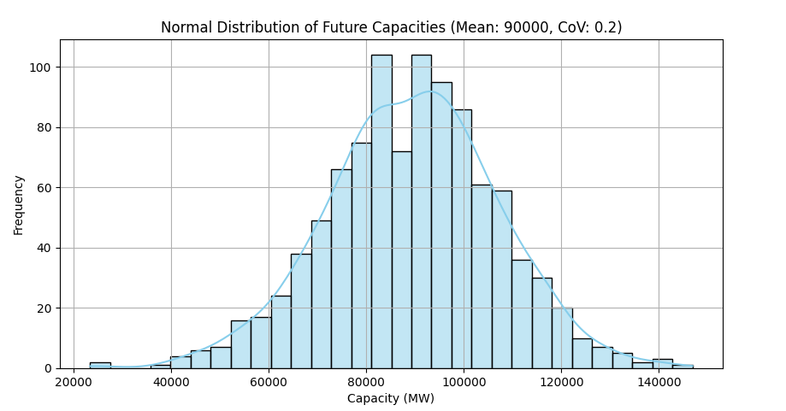
Example output of “Plot Future Capacity Distribution”
- Select Export and Simulate Future Reactors to start the simulation.
- The following pop-up window will appear. Select OK to continue.
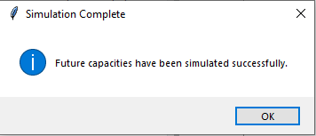
- A window will open to save the generated simulation file. Save the file in the same directory as your .exe file. The simulation file includes selected reactor types and indicates the number of reactors required (cumulative) to satisfy the future capacity defined.
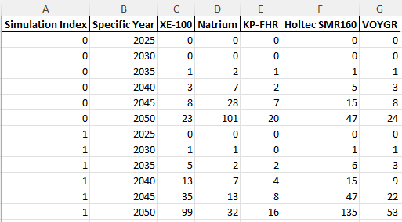
Example output showing format of generated Excel file
- Select Capacity Breakdown Future Reactors to display the share of generated capacity for each future reactor.
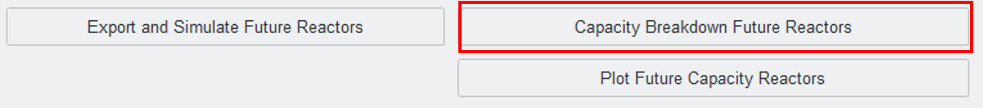
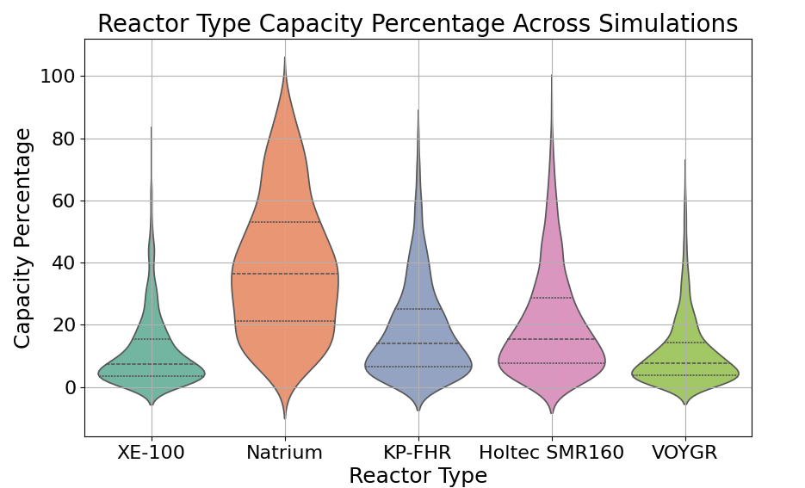
Example output of “Capacity Breakdown of Future Reactors”
- Select Plot Future Capacity Reactors to display the cumulative capacity generated by the future reactors for each simulation.
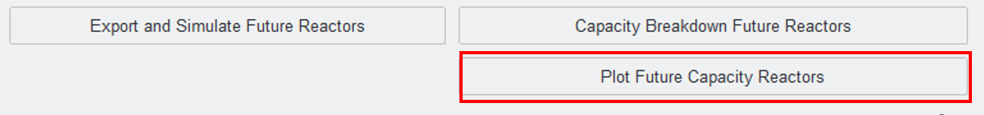
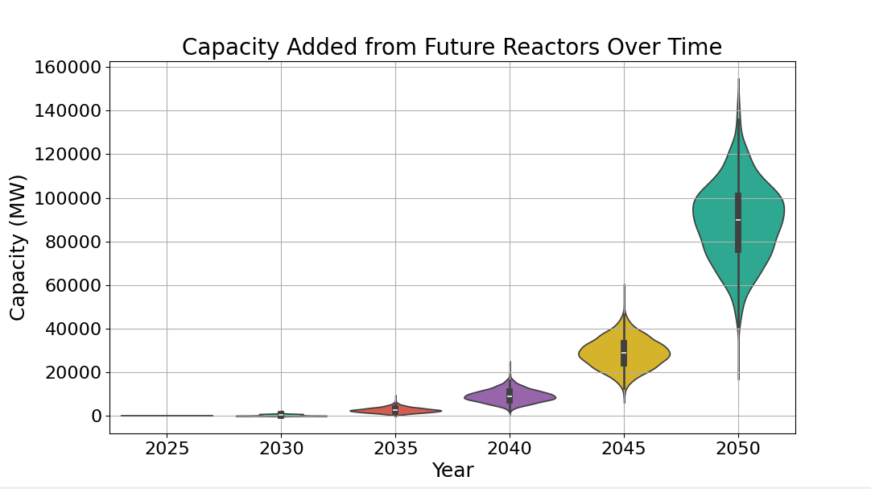
Example output of “Plot Future Capacity Reactors”
- In the Current Reactors section, select Browse to load the Current Reactors Excel File by selecting the provided Excel file or a modified file with the same format.
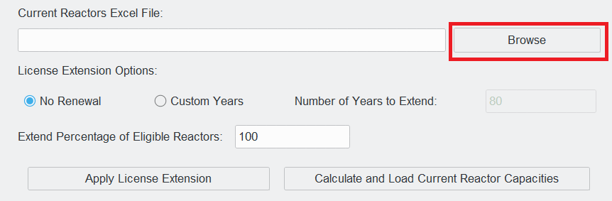
- Select the desired License Extension Option for current reactors.
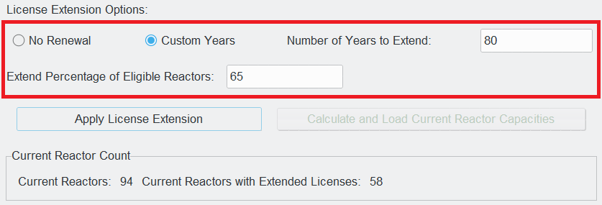
- Select Apply Extension. A message will be displayed stating that an Excel file with the applied extensions has been created in the SAME directory of .exe file.
- Select Calculate and Load Current Reactor Capacities.
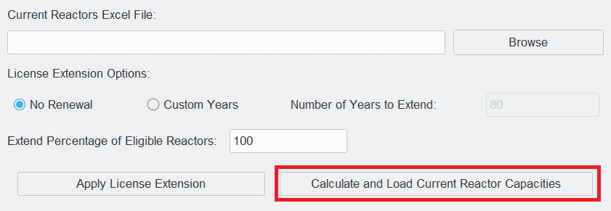
- The Current Reactor Count and Current Reactors Capacity text boxes will display the number of reactors with extended licenses and the projected capacities under the selected assumptions, respectively.
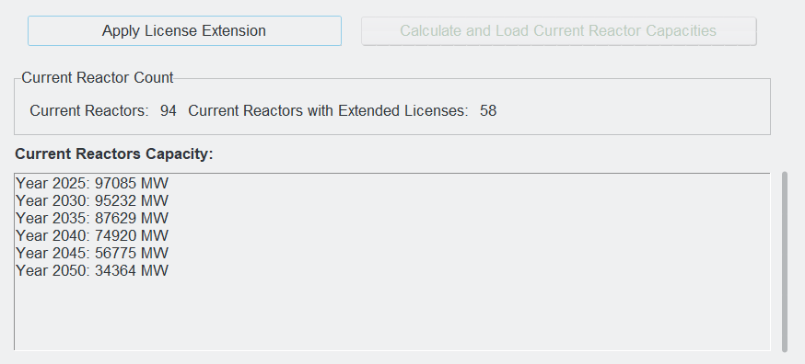
Example output of “Apply License Extension” showing projected future capacity of current reactors
- Select Plot Current Reactor Capacity to display the capacity over time generated by the assumption selected for the current reactors.
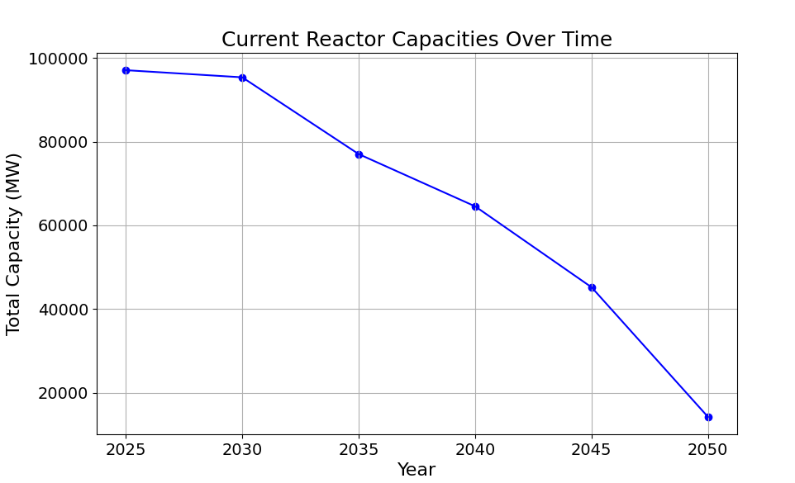
Example output of “Plot Current Reactor Capacity”
- Select Plot Total Capacity Projection to display the combined total capacity generated from current and future reactors.
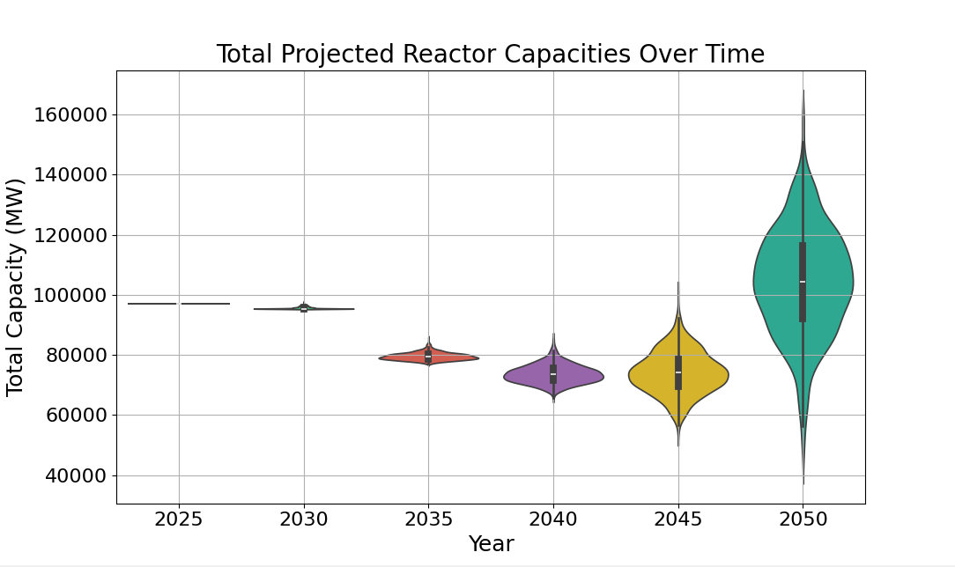
Example output of “Plot Total Capacity Projection”
- Select Fuel Cycle Demand to display the Fuel Cycle Demand window.
The following window will appear:
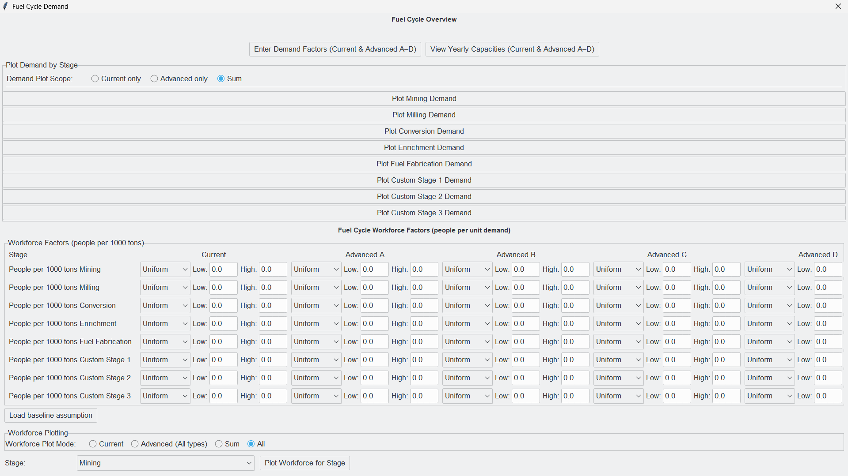
- Select Enter Demand Factors (Current & Advance A-D) to input the fuel demand.
- The following window will appear. Manually input the fuel demand in tonnes per GW for each stage of the fuel cycle OR select Load baseline assumptions to automatically fill the boxes with pre-determined values. Select Reset to Default to clear all values.
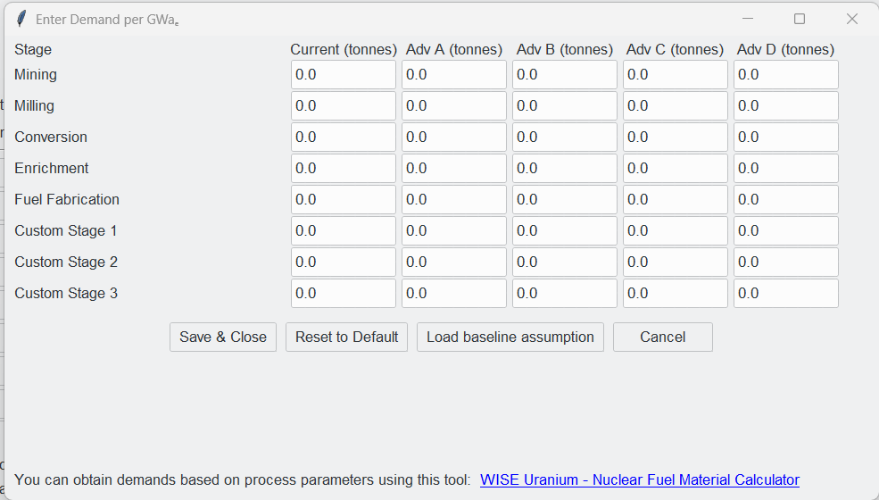
- The following pop-up window will appear. Select OK to close the pop-up window.
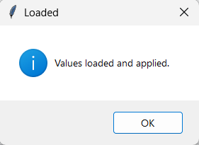
- Select Save & Close to close the Demand Factors window.
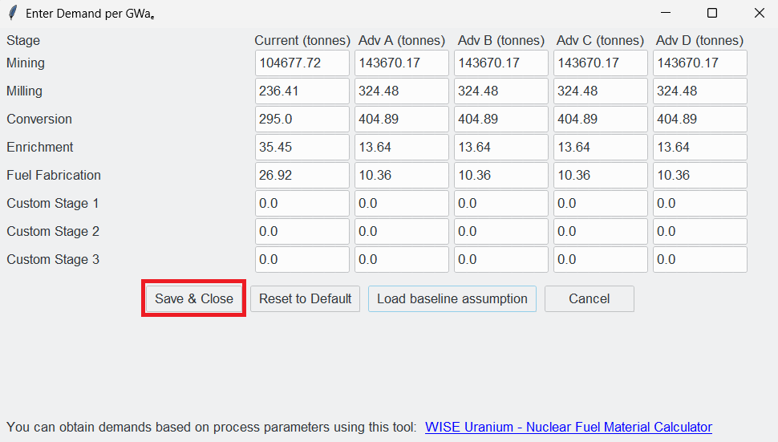

- Select View Yearly Capacities (Current & Advanced A-D) to view.
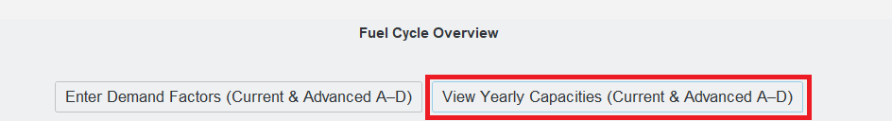
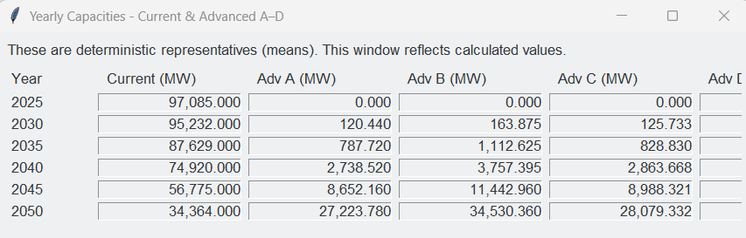
Example output of “View Yearly Capacities”
- Select Current, Advanced, or Sum as demand scope.
- Select one of the following stages to view projected uranium demand according to previously selected scope.
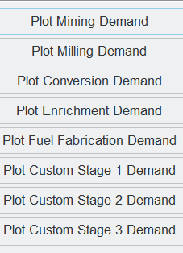
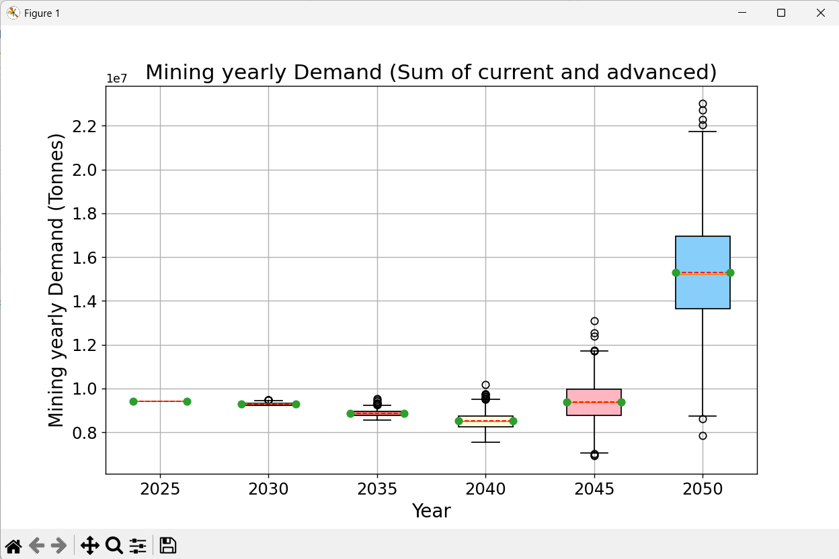
Example output plot of “Plot Mining Demand” (Scope: Sum)
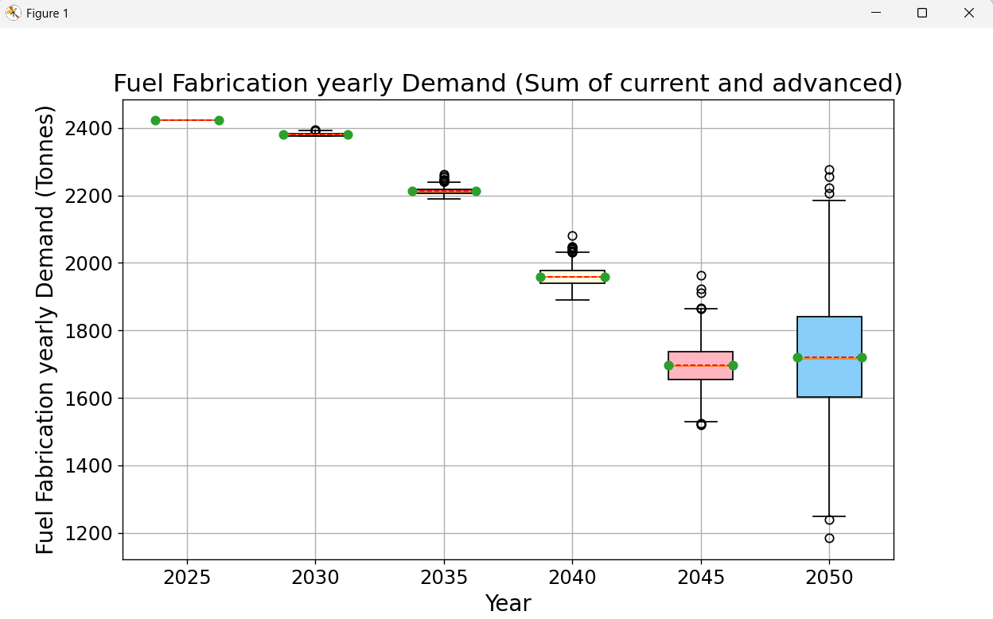
Example output of “Plot Fuel Fabrication Demand” (Scope: Sum)
- In the Fuel Cycle Workforce Factors window, manually input the workforce factors in workers per 1000 tons of material or select Load baseline assumption.
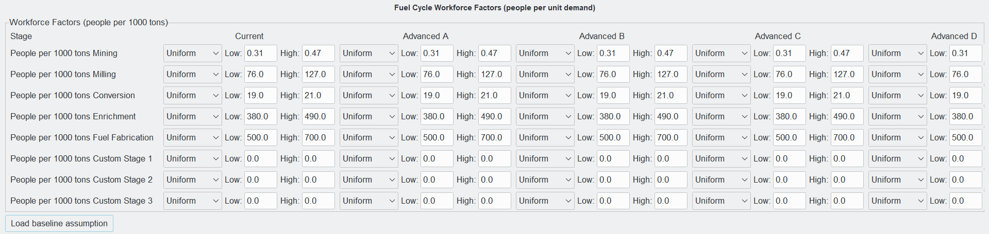
Fuel Cycle Workforce Factors Window with baseline assumptions
- Select Current, Advanced (All types), or Sum workforce plot mode.
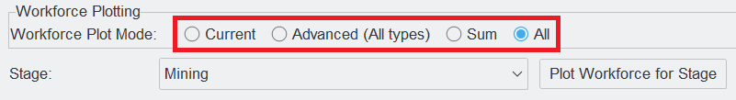
- Select the stage using the dropdown menu and select Plot Workforce for Stage. Plots will appear in sequence.
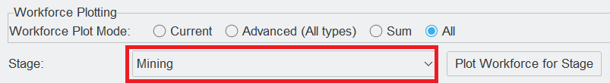
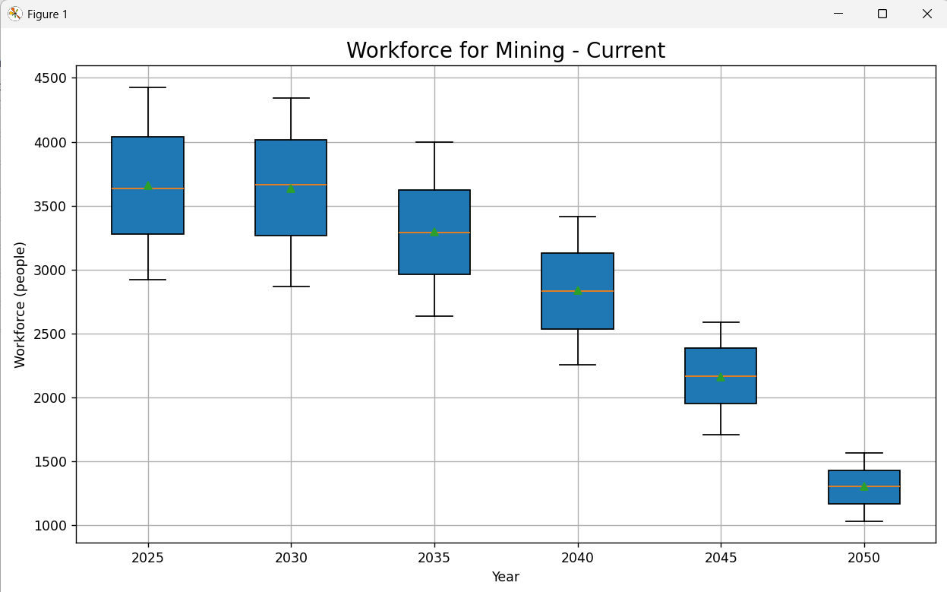
Example output of “Plot Workforce for Mining Stage” (Mode: Current)
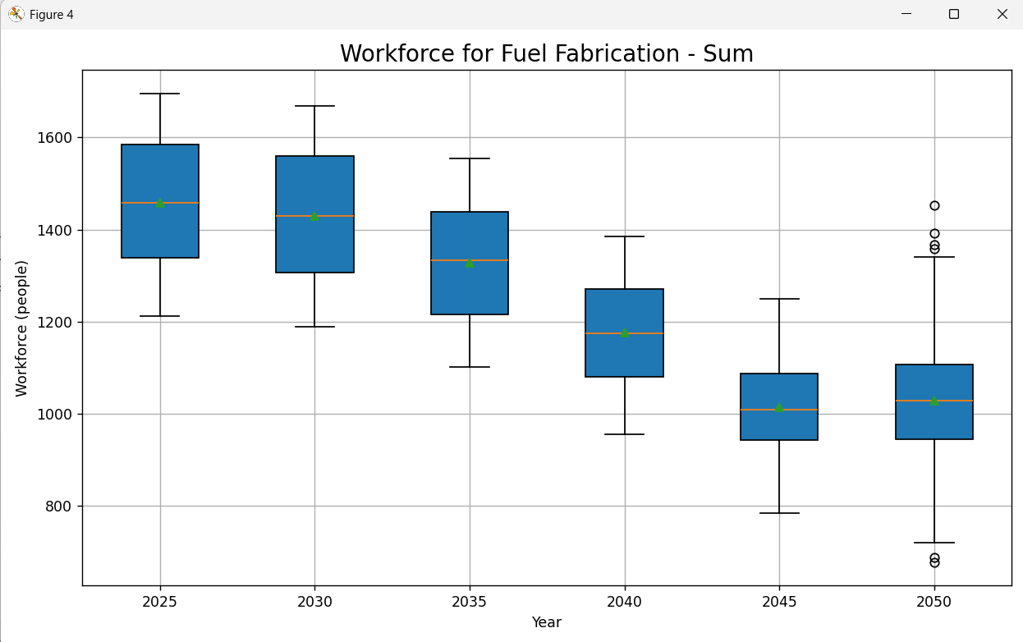
Example output of “Plot Workforce for Fuel Fabrication Stage” (Mode: Sum)
- Manually input assumed jobs per GW for current and future workforce distribution.
A good estimate for current reactors is 500 jobs/GW according to the Department of Energy.
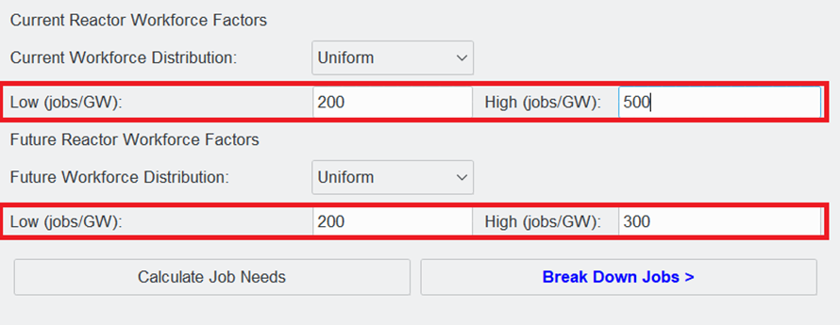
Example Input for Current Reactor Workforce Factors
- Select Calculate Job Needs to plot projected job market needs to operate the simulated capacity.
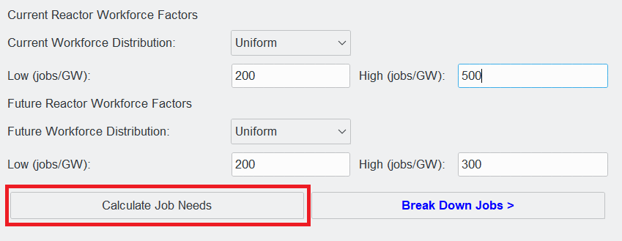
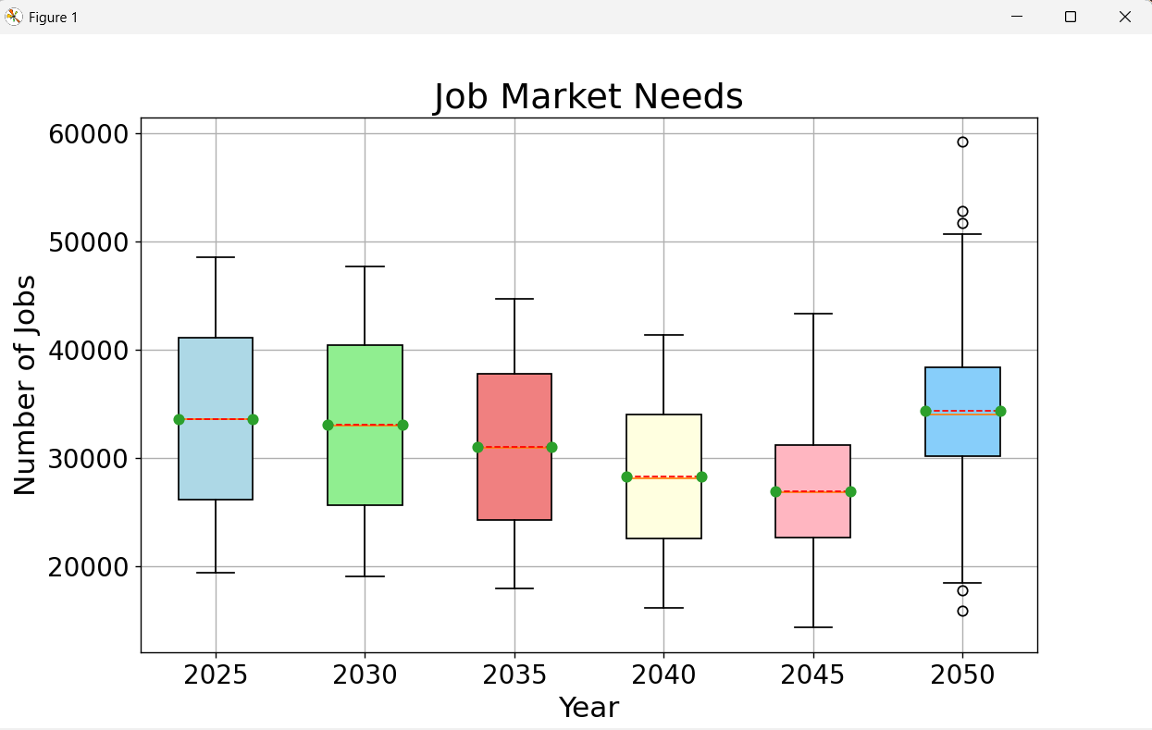
Example output of “Calculate Job Needs”
- Select Break Down Jobs to categorize the job demand.

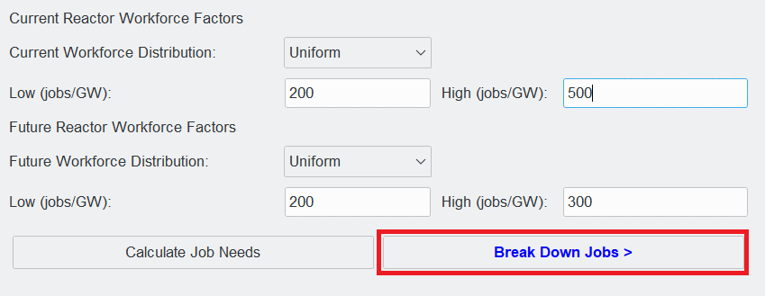
The following window will appear:
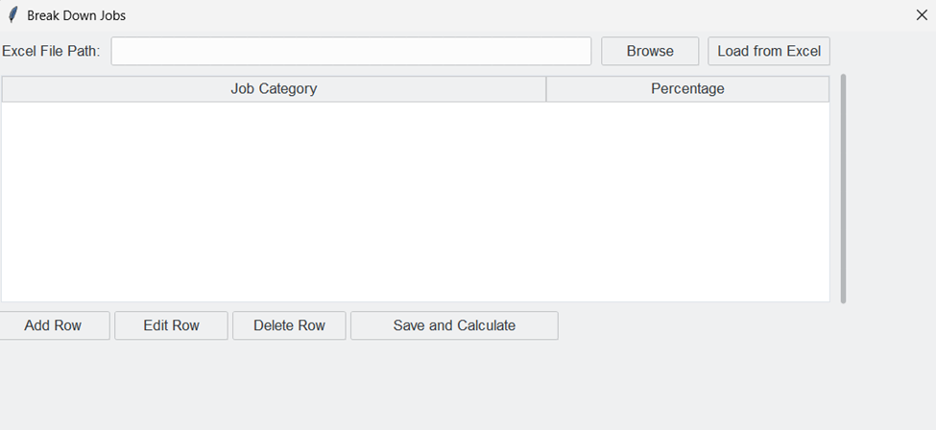
Break Down Jobs window
- An Excel file with the job categories and the percentages of the total job sector for nuclear industry is needed to predict job categorization. Use the provided Excel file or create your own using the format below. A good resource is the BLS Nuclear Electricity Generation Sector.
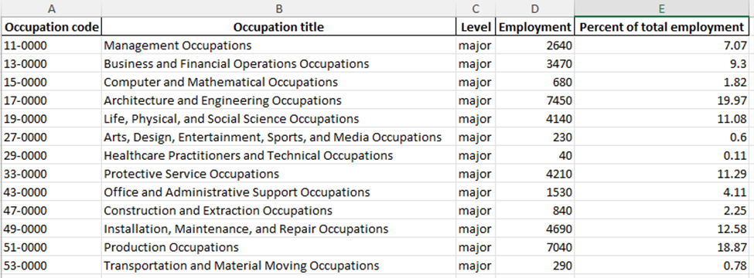
Example Excel sheet showing Workforce Numbers
The Excel file must have this exact format and column names. If the Occupation code, Level, or Employment is missing, input a value of 0 or N/A instead. The Occupation title and Percent of total employment inputs must be spelled exactly as shown above.
- Select Browse to choose the Excel file.
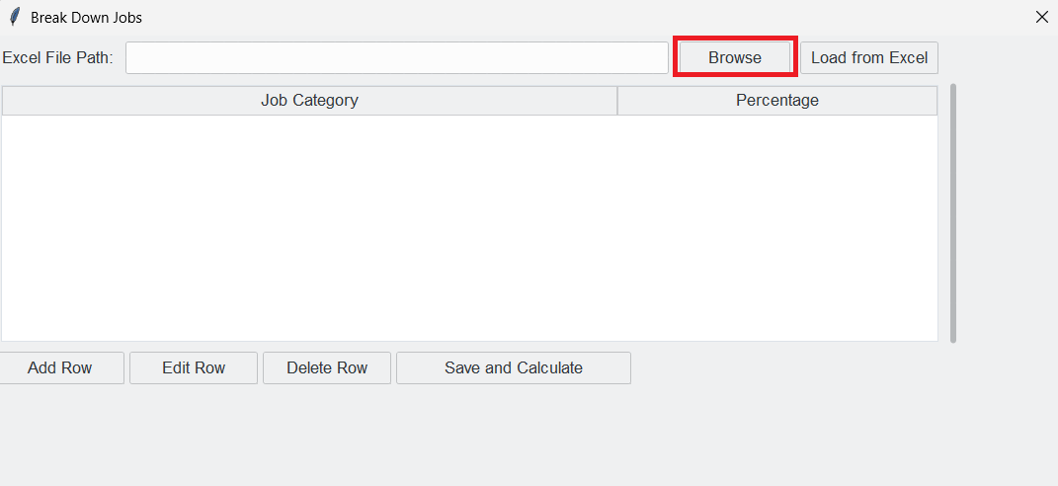
- Once chosen, select Load from Excel to add entries. Use Add Row, Edit Row, and Delete Row to manually adjust assumptions as needed.
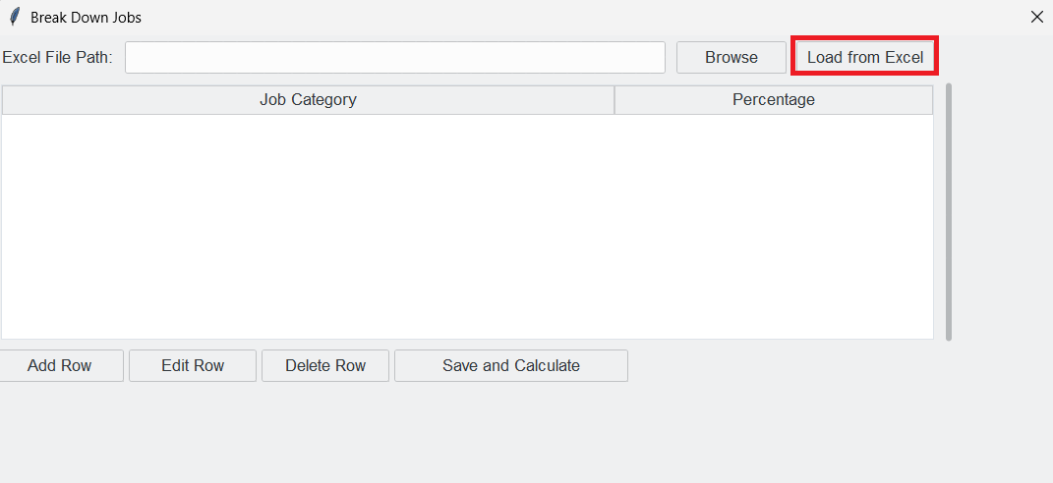
The following pop-up window will appear. Select OK to continue.
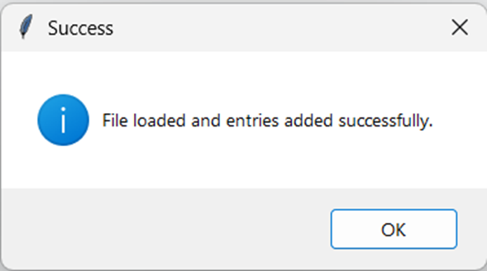
- Once the job categories are loaded, select Save and Calculate to plot the projected breakdown of job needs.
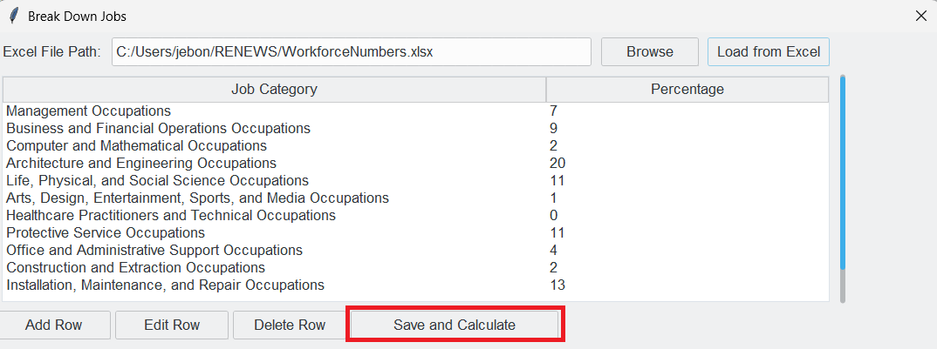
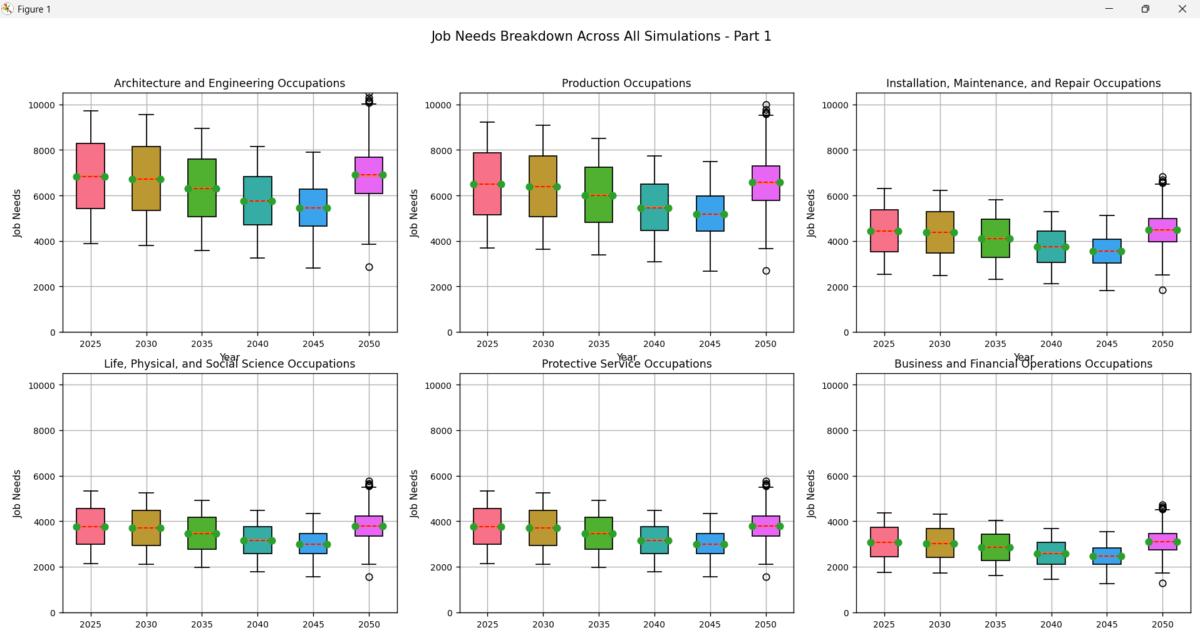
Example output for Break Down Jobs
- Exit out of the job breakdown window to continue. The following pop-up window will appear.
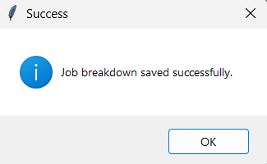
- Select OK to return to the main window.
